It’s your Birthday!!
Come and celebrate your special day with your
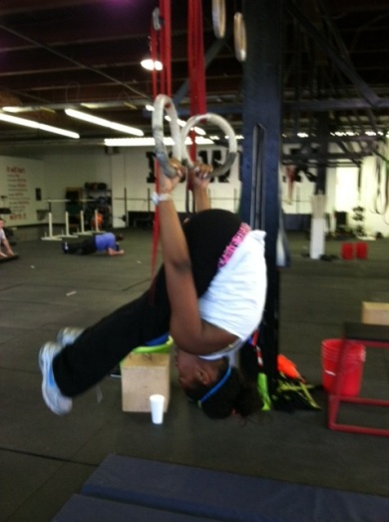
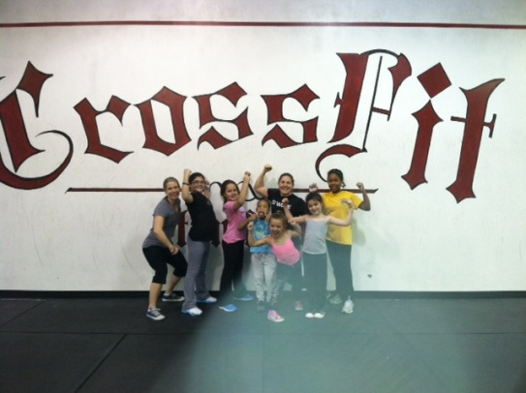
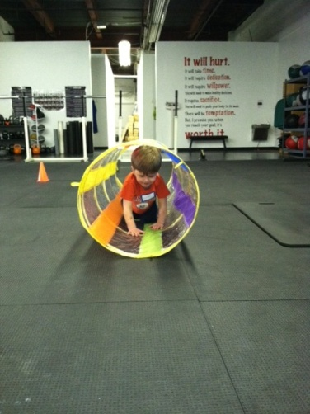
friends and family at “Kids Do Work” CrossFit Stamford.

Every Awesome Birthday Bash includes:

- Two certified CrossFit coaches
- A Kids Do Work T-shirt for the Birthday Child
- One goodie bag each for all the children
- Drinks for each child
- Lunch/Dinner
- All the paper goods (plates, forks, cups, napkins)
- All the set-up and clean-up

Visit us at: http://crossfitstamford.com/
Call or Email us today to get your party started!
203-569-2906
kidsdoworkcfs@gmail.com

